1. Create python script with web server returning hostname

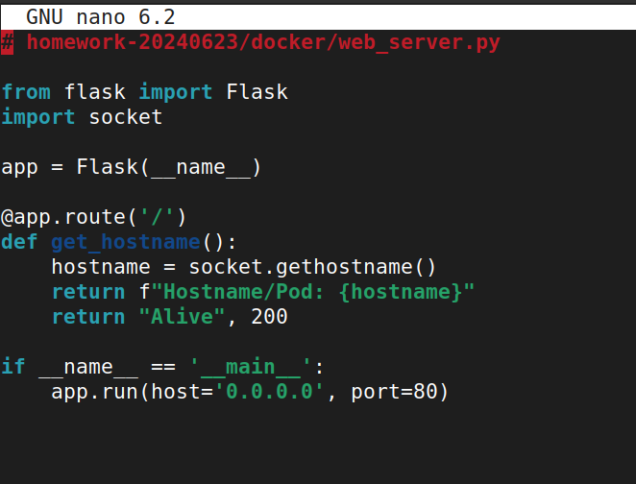

1. Build docker image with this script

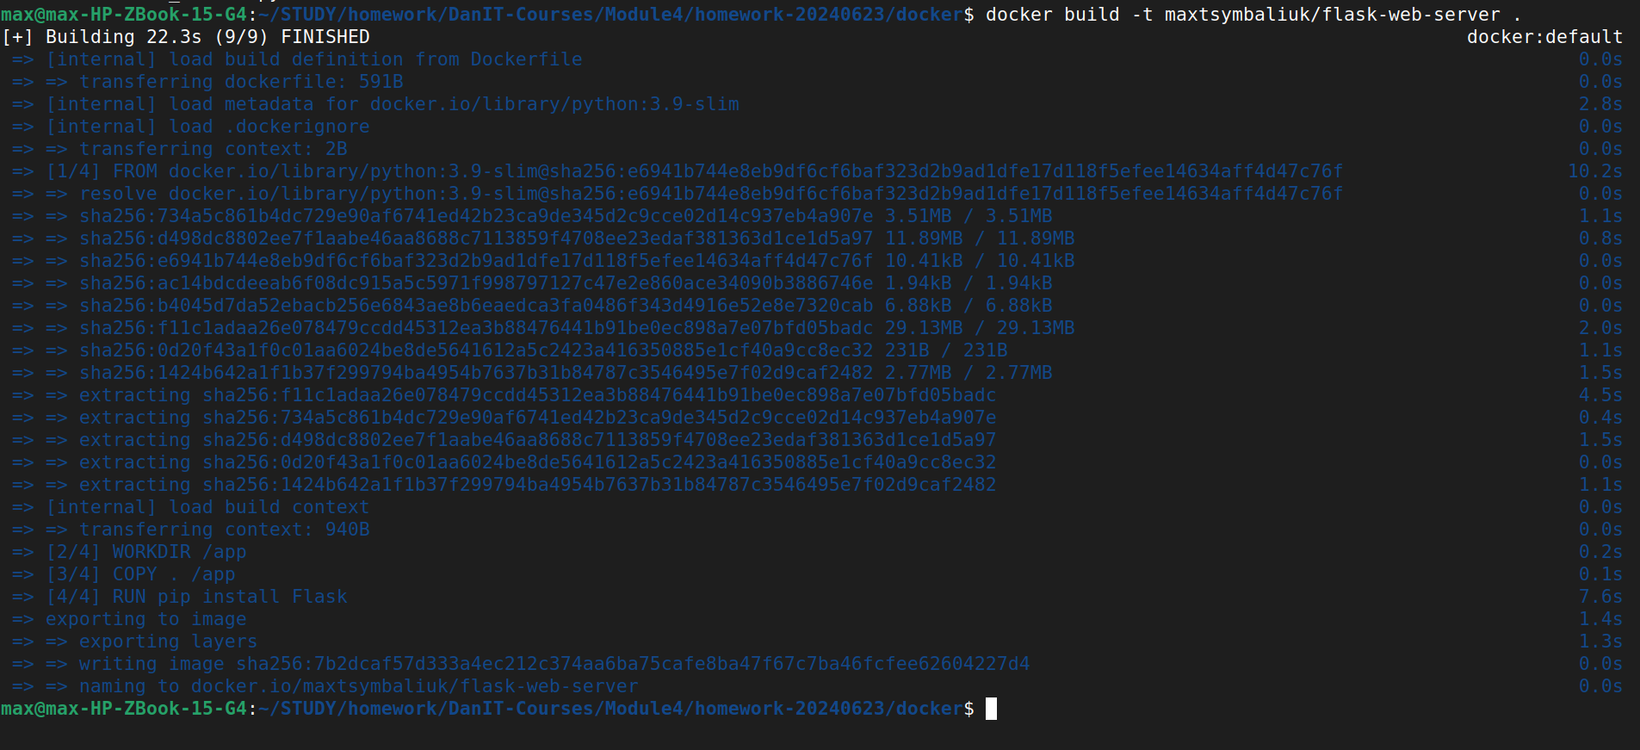

1. Push it to public registry

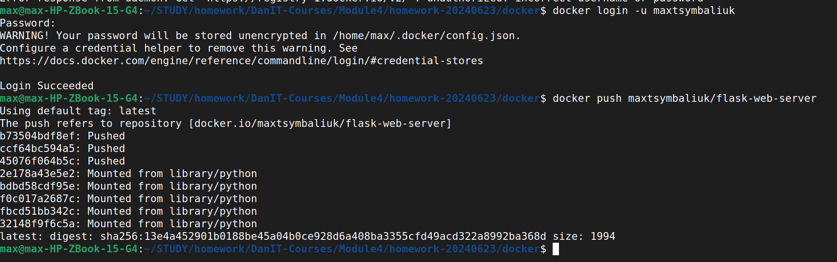

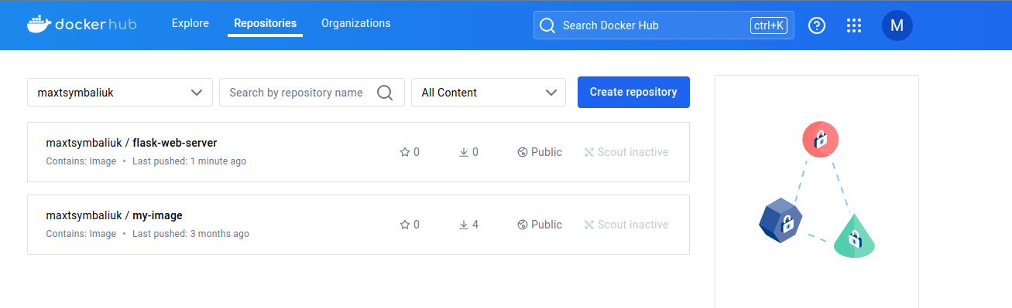

1. Create deployment with this image and 2-3 replicas

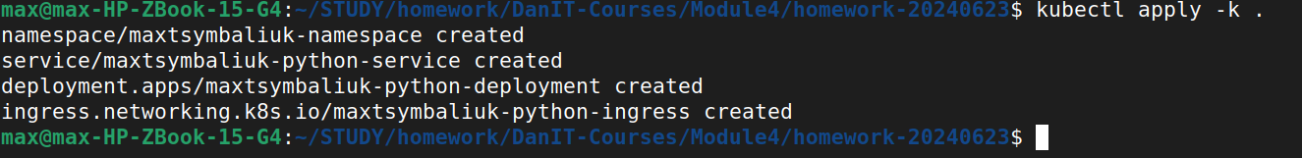

1. Create LoadBalancer service



1. Open LB domain and confirm that you see different hostnames